Configuration Guide

For

097 – OPC UA Server Plugin

Rev 2021-01-07 (for Plug-in Version v 5.121.0 or higher)
January 7, 2021

Table of Contents
Chapter 1 Enabling the OPC UA Server 3
1.1 About the OPC UA Server Plugin 3
1.2 Accessing the plugin dashboard 4
1.3 Starting the OPC UA server 5
1.4 Adding C-DEngine Thing data to the OPC UA Server 6
1.4.1 Customizing the OPC UA namespace/hierarchy: 8
1.5 Advanced Configuration 9

Enabling the OPC UA Server
This chapter covers enabling the OPC UA Server, and includes the following topics:
- About the OPC/UA Server Client Plugin
- Starting the OPC UA server
- Settings Groups: Device Status Group, Connectivity Group, Advanced Configuration Group, Security Group

About the OPC UA Server Plugin
The OPC UA (Unified Architecture) Server plugin enables access to C-DEngine Thing data using the OPC UA protocol. The NMI user interface allows selection of the Things to be exposed via OPC UA, as well as customization of the OPC UA namespace seen by OPC UA Clients. The same functionality is also available programmatically to accelerate development of other plugins.

Details on the OPC Unified Architecture can be found at the OPC Foundation website (https://opcfoundation.org/about/opc-technologies/opc-ua/).

Accessing the plugin dashboard
- The OPC UA Server user interface can be accessed via this button:
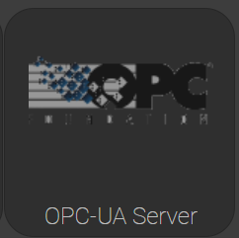
- When you click the OPC UA Server button, the OPC UA Server plugin dashboard appears (see Figure 2.4).
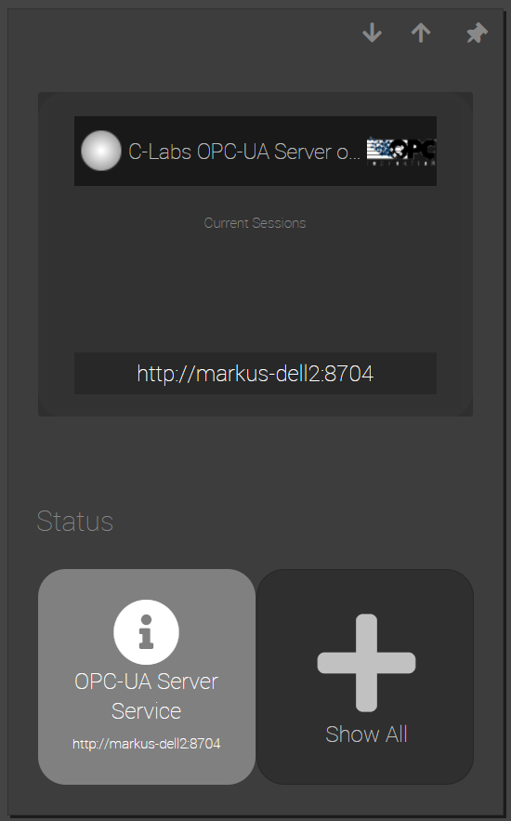
Figure 2.4. The OPC UA Server plugin dashboard.
- OPC UA is a client-server protocol. Our plugin provides the server. The first step in setting up this plugin involves starting the OPC UA server. To do that, click the C-Labs OPC UA Server button.

Starting the OPC UA server

Open the Start/Stop group, and click the Start button.
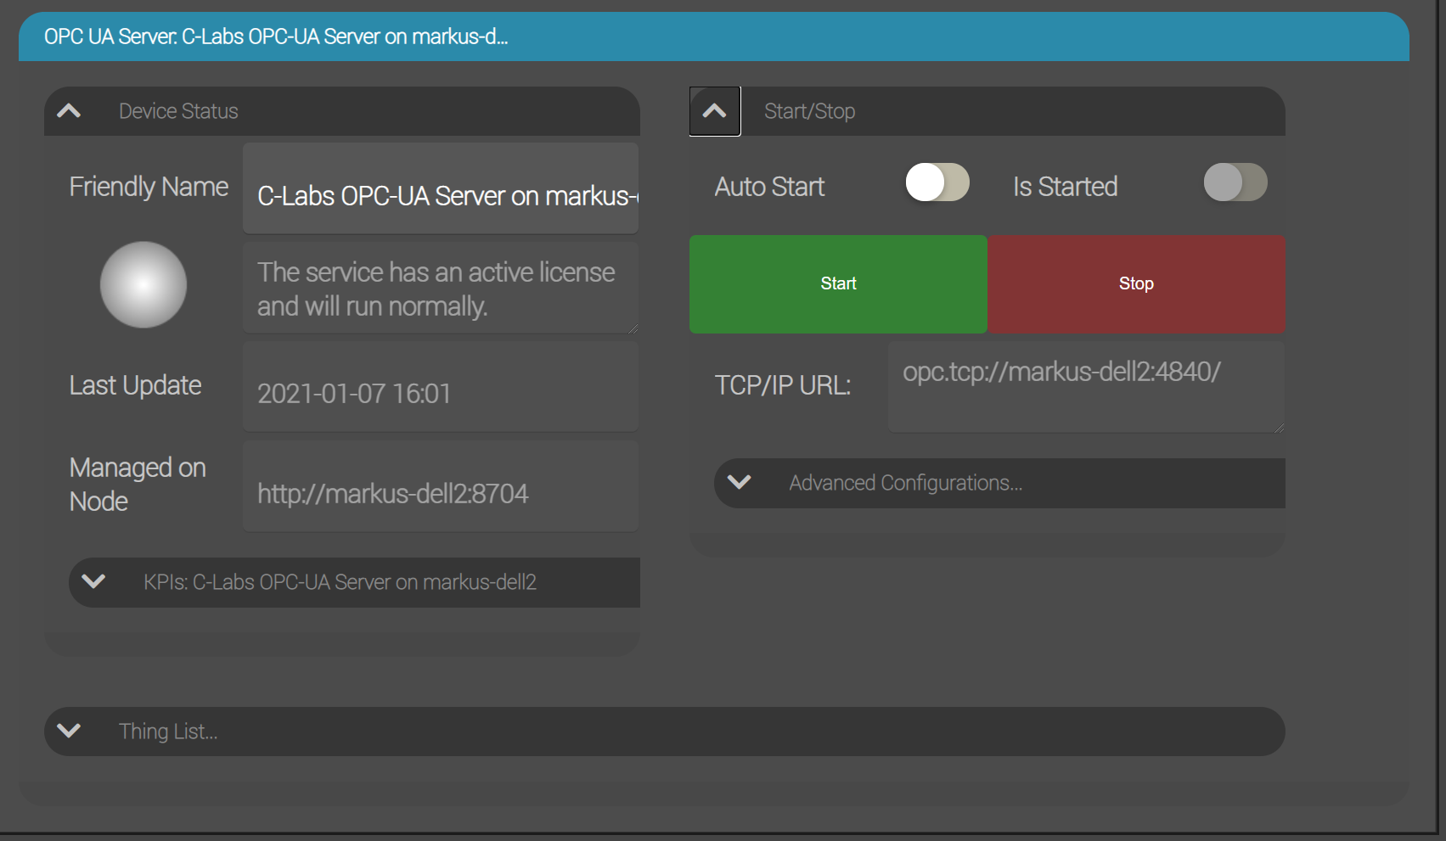
You can now connect to the OPC UA Server with any OPC UA Client, for example the UA Expert “UA Reference Client” by Unified Automation (used here for illustration), or the C-Labs OPC Client plugin.
The URL to be used is displayed in the dashboard.
By default, the connection requires a user name and password, which can be the same user account that you use to log into the Factory Relay.
At this point, you will only see general OPC UA diagnostic and meta data. For example in UA Expert:
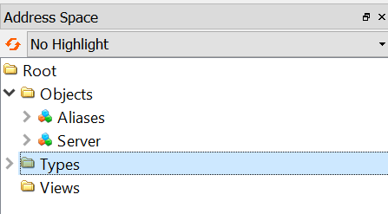

Adding C-DEngine Thing data to the OPC UA Server

- Open the Thing List group and click on the Add new Thing Button:
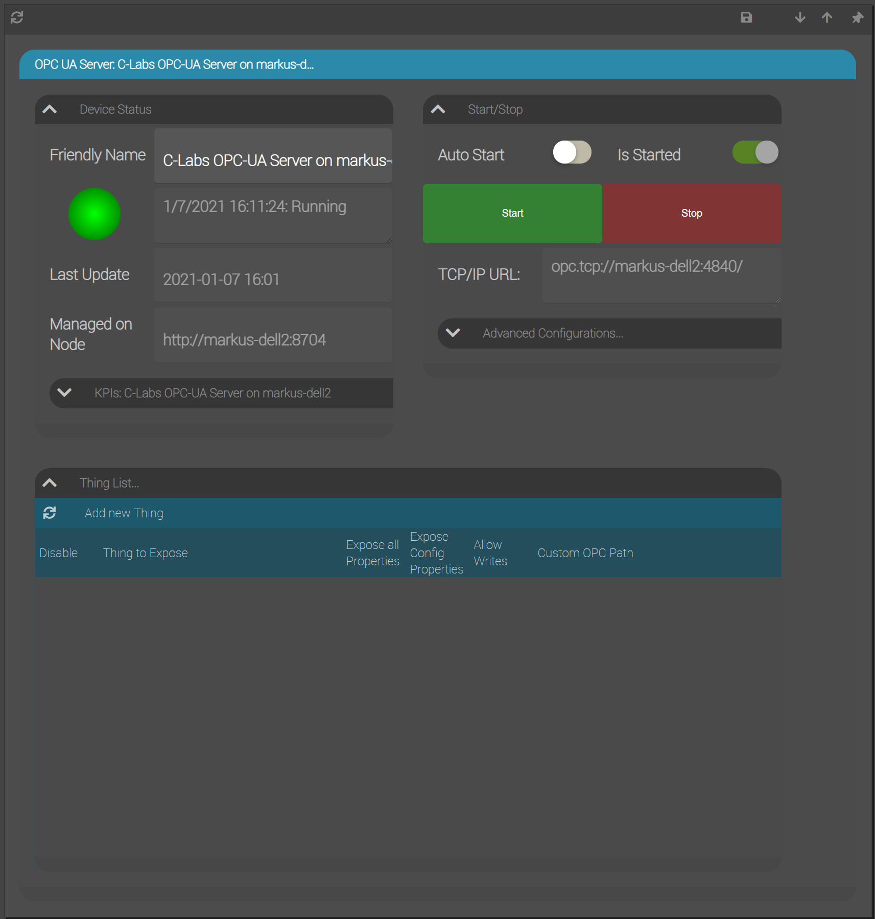
- Select the thing you want to expose via OPC UA and press enter:
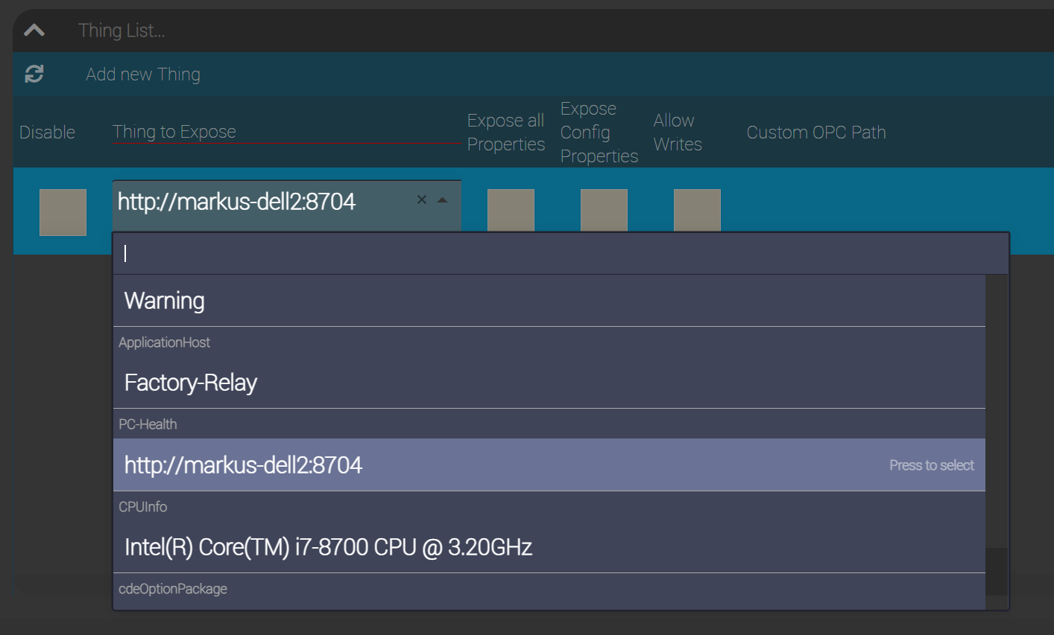
Note: You may have to stop and start the OPC UA Server for the new thing to become available to previously connected OPC UA Clients.
The new thing will now appear in the OPC UA namespace, for example:
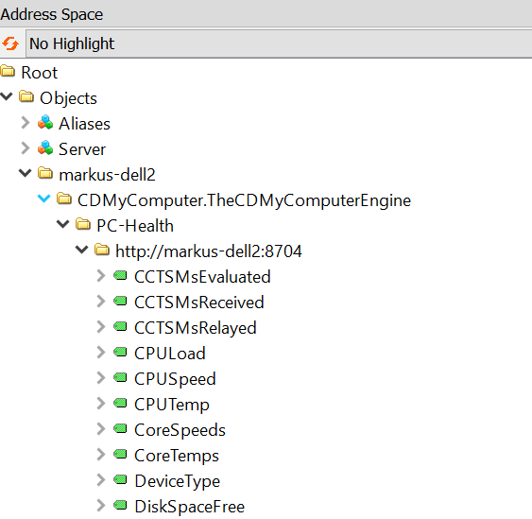
The default OPC UA Namespace hierarchy is composed as follows:
[hostname]: the DNS name of the Factory Relay
[plug-in name]: the name of the plug-in that provides the thing, in this case CDMyComputer.TheCDMyComputerEngine
[Device Type]: the device type of the thing, in the case “PC-Health”.
[Friendly Name]: the Friendly Name of the thing, in this example the relay’s http URL.

Customizing the OPC UA namespace and the exposed properties

You can customize this hierarchy by editing the Custom OPC Path field for each thing in the Thing List:
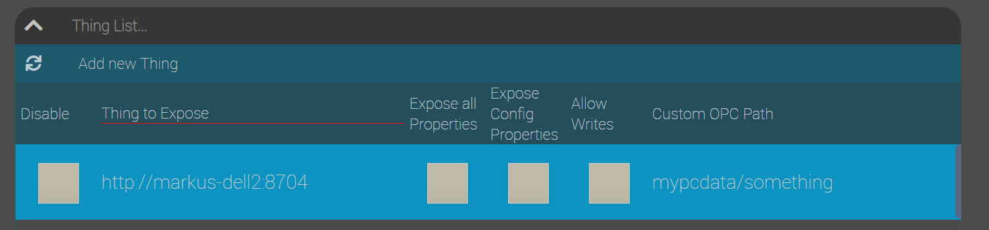
Example: mypcdata.something will result in
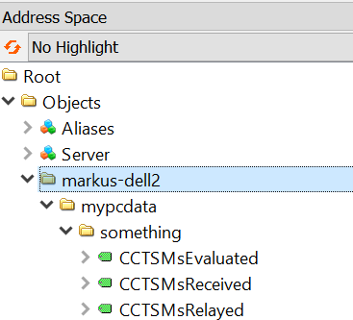
Entering /mypcdata.something will result in this hierarchy (no scoping by the Factory Gate’s host name):
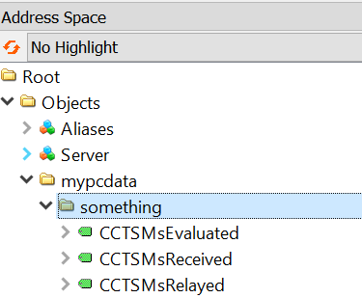

You can specify the following additional options for each thing:
Expose all Properties | Some things indicate which properties are Sensor values. Select this option if you want to expose all properties of such a thing, instead of just the Sensor value properties (Default).
Expose Config Properties | Things that indicate Sensor values may also indicate which properties contain configuration values. Select this option if you want to expose these configuration properties in addition to Sensor Values.
Allow writes | Allows OPC UA Clients to write values in the all properties of this thing.

Advanced Configuration

To configure the OPC Server open the Advanced Configuration group:
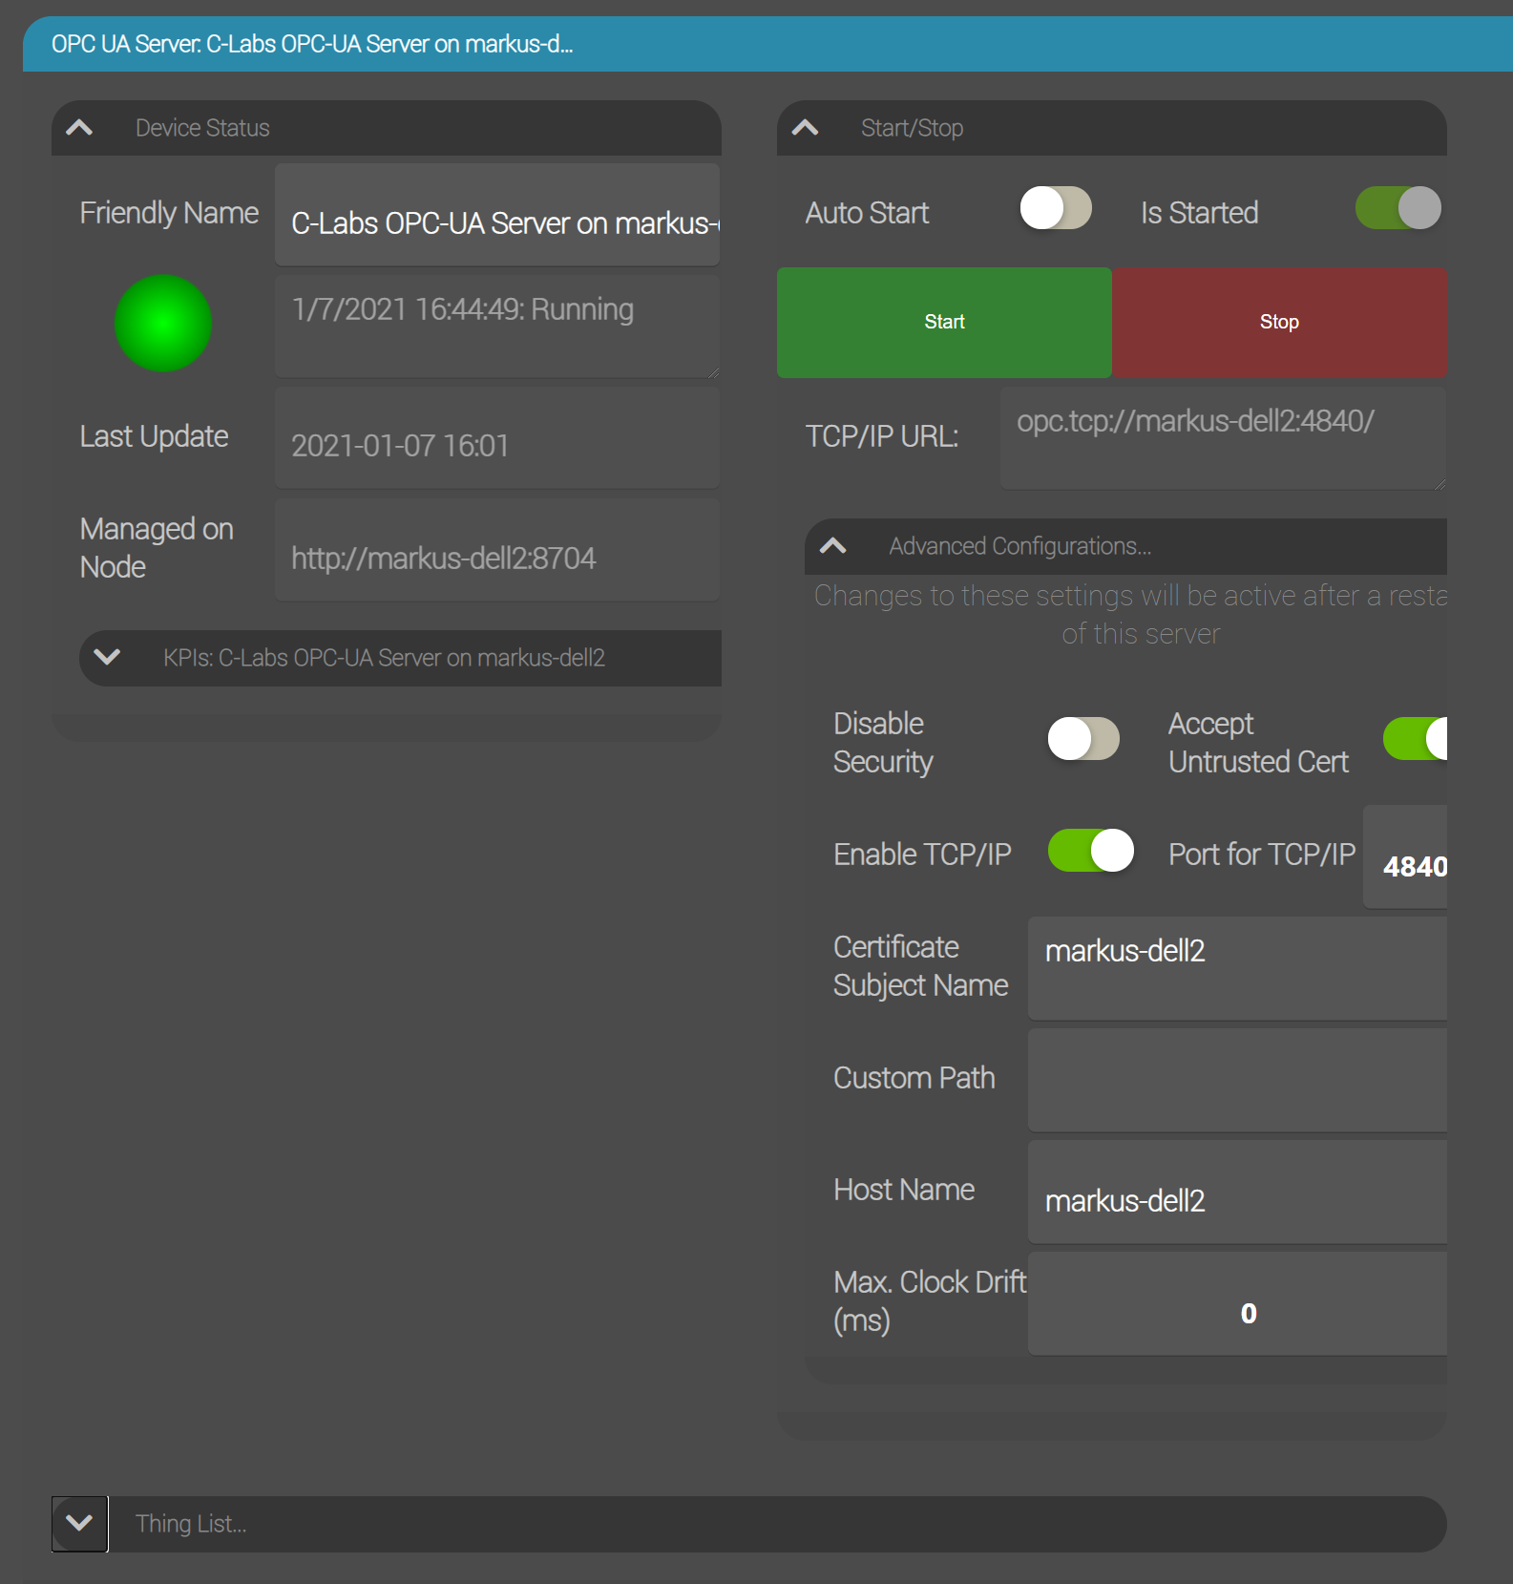
Here you can find the following options:
Disable Security | Allows anonymous access (no username/password required, no OPC UA encryption)
Accept Untrusted Cert | If this is unchecked, the OPC UA client must present an X509 certificate from an issuer or certificate authority that is trusted by the hosting operating system.
Certificate Subject Name | The OPC UA server generates a self-signed X509 certificate using this Subject Name. OPC UA Clients can use this certificate to verify that they are connected to the correct server.  Default: DNS name of the Factory Relay host.
Port | Change this if you want to use a TCP/IP port different from the standard OPC UA port 4840.
Host Name | Change if you want to use a different host URL in the OPC UA discovery mechanism.
Custom Path | Specify a relative URL to be appended to the TCP/IP URL.
Max Click Drift (ms) | By default, the OPC UA Server allows clock drift between clients and the server of up to 10 minutes (600000 ms).

KPIs

Click on the KPIs group to see Key Performance Indicators of the OPC UA Server:
